

**CAR RESALE VALUE PREDICTION**

**Professional Readiness for Innovation, Employability and Entrepreneurship**

**PROJECT REPORT**

***Submitted by Team ID:PNT2022TMID12043***

**RESHMA V**                        **73151913075**

**SRI HARI V 73151913089**

**YAVANIKA V**                    **73151913107**

**SOUNDHIRARAJAN C     73151913507**

***in partial fulfillment for the award of the degree***

***of***

**BACHELOR OF ENGINEERING**

**IN**

**COMPUTER SCIENCE AND ENGINEERING**

**K.S.R COLLEGE OF ENGINEERING**

**ANNA UNIVERSITY: CHENNAI 600 025**

**NOVEMBER 2022**

**ANNA UNIVERSITY: CHENNAI 600 025**

**BONAFIDE CERTIFICATE**

Certified that this project report **“CAR RESALE VALUE PREDICTION”** is the bonafide work of **“RESHMA V (731519131075), SRI HARI V (73151913089), YAVANIKA V (73151913107) and SOUNDHIRARAJAN C (73151913507)”,** who carried out the project work under my supervision.

**SIGNATURE:                                                  SIGNATURE:**

**Dr. A RAJIV KANNAN., Ph.D.,                   Mrs. V SHANMUGAVALLI**

**HEAD OF THE DEPARTMENT,                MENTOR,**

**Department of Computer Science                 Department of Computer Science**

**and Engineering.                                             and Engineering.**

**K S R College of Engineering                       K S R College of Engineering**

**Tiruchengode-637 215                                   Tiruchengode-637 215**

**CHAPTER 1**

**INTRODUCTION**

**1.1 OVERVIEW**

Car resale value prediction system is made with the purpose of predicting the correct valuation of used cars that helps users to sell the car remotely with perfect valuation and without human intervention in the process to eliminate biased valuation.

**MACHINE LEARNING**

         Machine Learning is a field of technology developing with immense abilities and applications in automating tasks, where neither human intervention is needed nor explicit programming. The power of ML is so great that we can see its applications trending almost everywhere in our day-to-day lives. ML has solved many problems that existed earlier and have made businesses in the world progress to a great extent. To develop an efficient and effective model which predicts the price of a used car according to the user's inputs.

➢ To achieve good accuracy.

➢ To develop a User Interface( UI )

➢ It is user-friendly

➢ It takes input from the user and predicts the price.

**1.2 PURPOSE**

      The main idea of making a car resale value prediction system is to get hands-on practice for python using Data Science. Car resale value prediction is the system to predict the amount of resale value based on the parameters provided by the user. User enters the details of the car into the form given and accordingly the car resale value is predicted

**1.3 OBJECTIVE**

 Car resale value prediction system is made with the purpose of predicting the correct valuation of used cars that helps users to sell the car remotely with perfect valuation and without human intervention in the process to eliminate biased valuation.

The new system developed by us consists of two parts - Data gathering and Prediction using Machine Learning based algorithms

The second part is the web-based car resale value prediction. We have trained a boosting algorithm-based ML model using data from the previous step after preprocessing and cleaning. The trained model is used for prediction. The front-end form asks users to fill values which are required for the ML model to make prediction IE- city, kms driven, year of purchase and fuel type.

**CHAPTER 2**

**LITERATURE SURVEY**

**Author**: Kiran

**Description**: This paper deals with the expected estimate for resale value of a car is most significant in the field of present research and technology. Most significant attributes are considered for predicting the resale value of the car. The significant relationships among various attributes are found by establishing the correlations. In this research the price of the car is considered as a dependent variable for target prediction. The data used for prediction was taken from the web. The suitability of random forest regression algorithm is identified and implemented in this research work for accurately predicting the resale value of the vehicle based on most significant attributes that have been selected on the basis of highest correlation. The outcome of the research shows that the accuracy of the model built is up to 90 percent and error obtained is 10 percent. **Author :** Prashant Gajera, Akshay Gondaliya, Jewish Kathiawar

**Description :** This paper deals with car price prediction with a platform that helps the people. The upcoming data with that platform which is made using machine learning technology. Using supervised machine learning algorithms such as linear regression , random forest regression . It helps to build a statistical model which will be able to predict the price of a used car . For that, previous consumer data and a given set of features will help us. It will also be comparing the prediction accuracy of these models to determine the optimal one.

**Author**: Pattabiraman Venkatasubbu, Mukkesh Ganesh

**Description** : This paper deals with the fact that the production of cars has been steadily increasing in the past decade, with over 70 million passenger cars being produced in the year 2016. This has given rise to the used car market, which on its own has become a booming industry. The recent advent of online portals has facilitated the need for both the customer and the seller to be better informed about the trends and patterns that determine the value of a used car in the market. Using Machine Learning Algorithms such as Lasso Regression, Multiple Regression and Regression trees, we will try to develop a statistical model which will be able to predict the price of a used car, based on previous consumer data and a given set of features. We will also be comparing the prediction accuracy of these models to determine the optimal one.

**CHAPTER 3**

**IDEATION AND PROPOSED SOLUTION**

**3.1 EMPATHY MAP CANVAS**

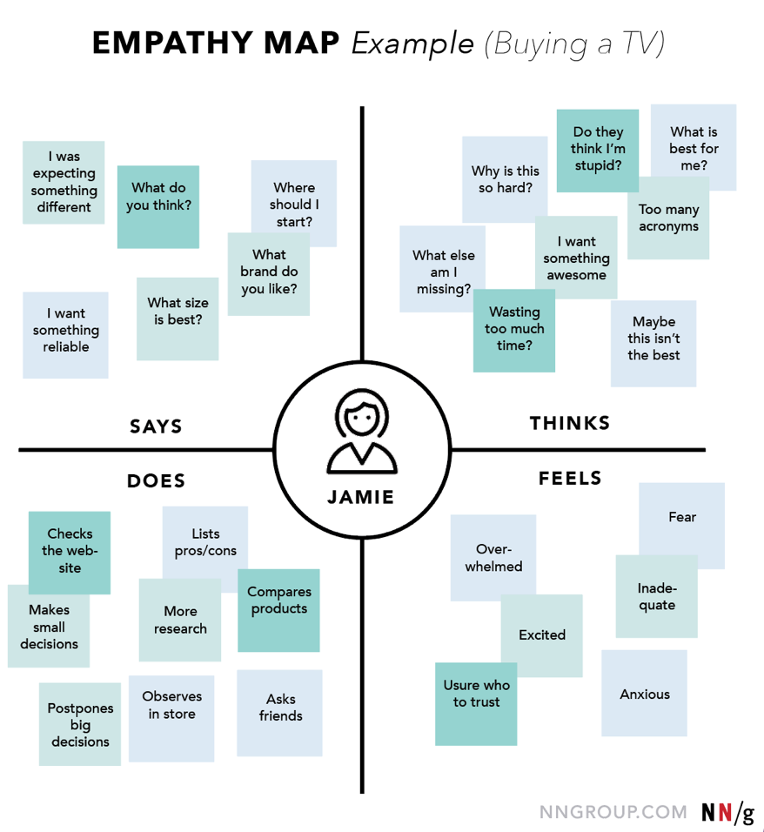

**3.2 IDEATION AND BRAINSTROMING**

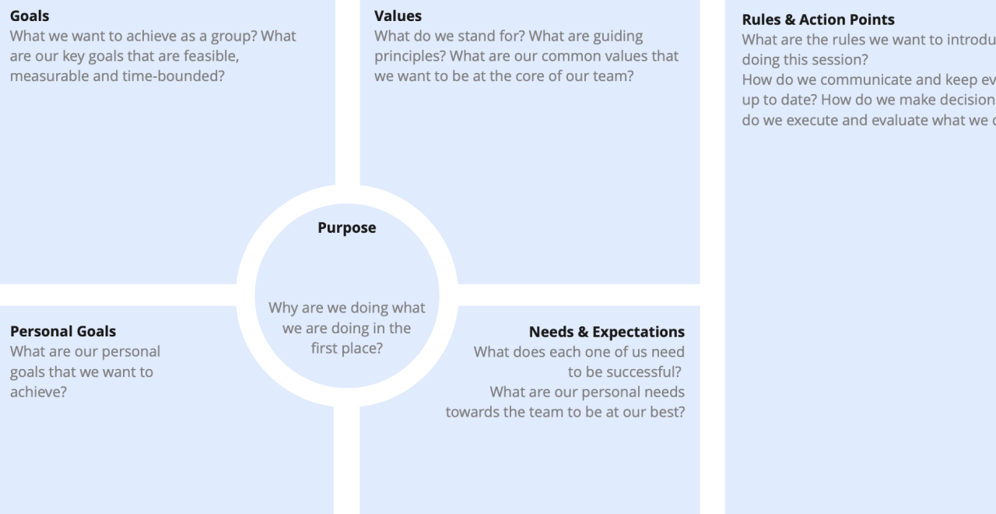

**3.3 PROPOSED SOLUTION**

|  |  |  |
| --- | --- | --- |
| **S.No.** | **Parameter** | **Description** |
| 1. | Problem Statement (Problem to be solved) | If anyone wants to sell their car,either they have to take their car to a respective company workshop or have to make an appointment for the company to get an estimate of the price. This process involves a lot of time and resources. |
| 2. | Idea / Solution description | Car resale value prediction system is made with the purpose of predicting the correct valuation of old cars that helps customers to sell the car remotely with perfect valuation and without human intervention in the process which saves the time of the customer. |
| 3. | Novelty / Uniqueness | Our Objective is to make a model for third-party companies that will make an estimate the Price of the customer’s car directly from their online portal rather than asking price information from third person. Easy to predict the used car price. |
| 4. | Social Impact / Customer Satisfaction | Customer satisfaction is more important here our car resale value prediction provides a more accurate price for the used car and it takes less time to find which satisfies the customer need. |
| 5. | Business Model (Revenue Model) | **Business-2-consumer business model**  Business-2-consumer business model is a model that refers to businesses that sell their services or the products directly to the consumer who are the end users of the products or services. |
| 6. | Scalability of the Solution | Our solution provides approximately 0.7 accuracy for training dataset and 0.6 accuracy for test dataset. |

**3.4 PROPOSED SOLUTION FIT**

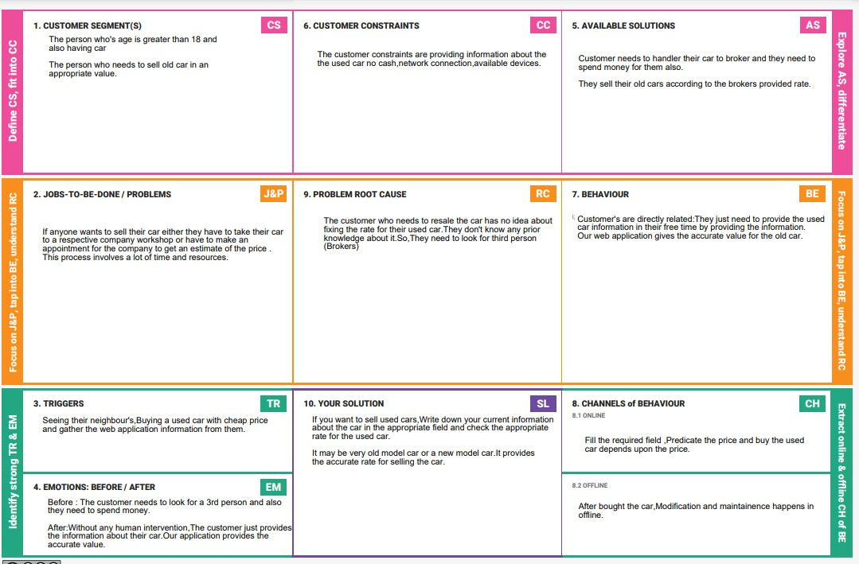

**CHAPTER 4**

**REQUIREMENT ANALYSIS**

**4.1 FUNCTIONAL REQUIREMENTS:**

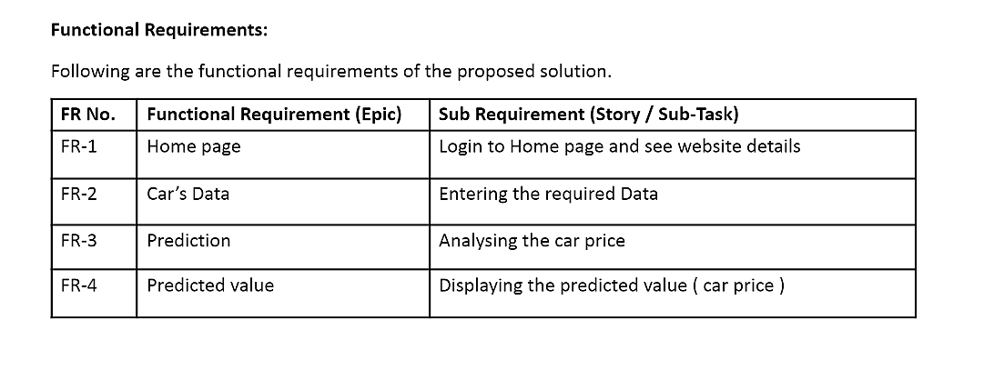

**4.2 NON-FUNCTIONAL REQUIREMENTS:**

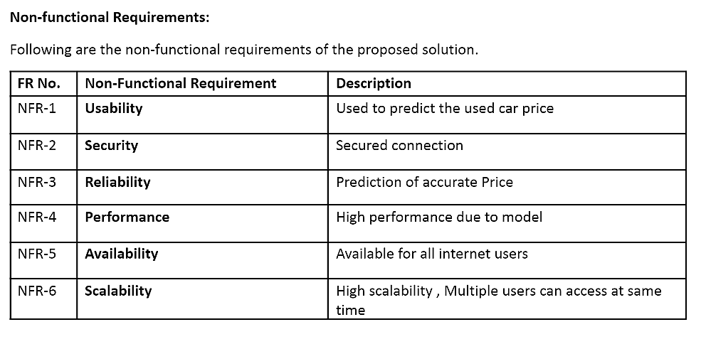

**CHAPTER 5**

**PROJECT DESIGN**

**5.1 DATA FLOW DIAGRAMS:**

A Data Flow Diagram (DFD) is a traditional visual representation of the information flows within a system.This diagram shows the flow of our project here the actor is the user who needs their resale car price .

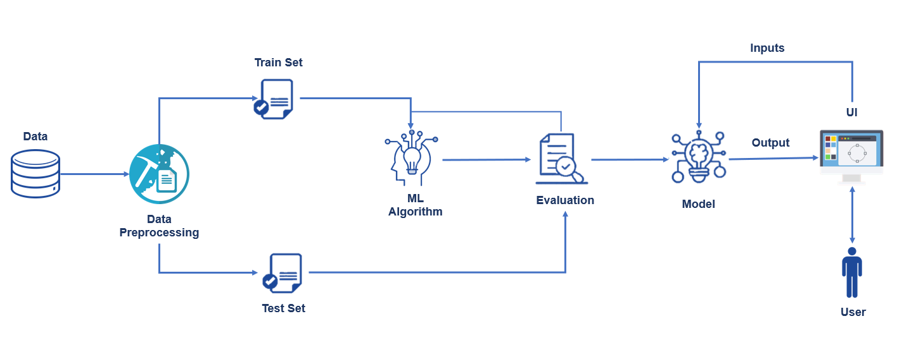

**5.2 SOLUTION AND TECHNICAL ARCHITECTURE:**

**Technical Arichitecture:**

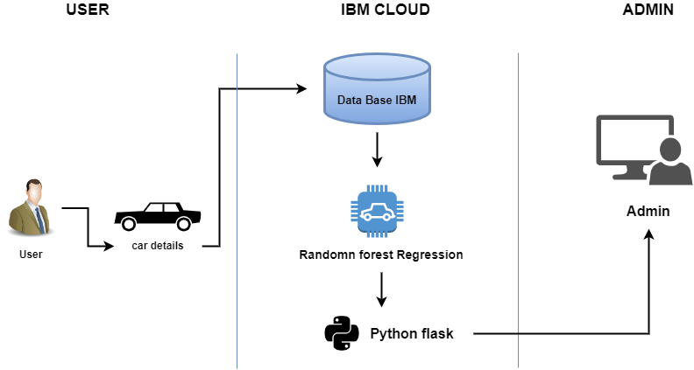

**Table-1 : Components & Technologies:**

|  |  |  |  |
| --- | --- | --- | --- |
| **S.No** | **Component** | **Description** | **Technology** |
| 1. | User Interface | The user interacts with application using  Web UI. | HTML, CSS, JavaScript , ReactJS etc. |
| 2. | Database | The dataset containing car details is used for  training the model to predict the rate. | Python libraries like numpy, pandas etc. |
| 3. | Cloud Database | The dataset is stored in the IBM cloud | IBM Cloud |
| 4. | Machine Learning algorithms | The machine learning algorithms are used to  predict the used cars rate. | Random forest Regression algorithm |

**Table-2: Application Characteristics:**

|  |  |  |  |
| --- | --- | --- | --- |
| **S.No** | **Characteristics** | **Description** | **Technology** |
| 1. | Open-Source Frameworks | Open-source frameworks used | Python Flask, Python, IBM Cloud |
| 2. | Scalable Architecture | Scalability of architecture consists of 3 tiers | Web server-HTML, CSS, Java script Application server-Python Flask Database server-IBM Cloud |
| 3. | Availability | The user can access through cloud | IBM Cloud hosting |
| 4. | Performance | Multiple users can access the web application | IBM Load Balance |

**5.3 USER STORIES:**

|  |  |  |  |  |  |  |
| --- | --- | --- | --- | --- | --- | --- |
| **User Type** | **Functional Requirement (Epic)** | **User Story Number** | **User Story / Task** | **Acceptance criteria** | **Priority** | **Release** |
| customer (web user) | Dashboard | USN-1 | User can visit the Home page | I can access website Details | Medium | Sprint-1 |
|  | Car Details | USN-2 | Users should give their requirements like model , year , fuel type , owner etc.. | I should give the car details | High | Sprint-2 |
|  | Car Price | USN-3 | User can see the current price of the car | I can see the car price | High | Sprint-4 |
| Admin | Model Building | USN-4 | Admin should train and test the data set given | I can build train and test the model | High | Sprint-3 |
|  | Predict chart | USN-5 | Admin should get the data set and predicted value of the car | I can predict the car price | High | Sprint-3 |
|  | Predict | USN-6 | Admin should display the predicted price | I can display the car price | High | Sprint-4 |

**CHAPTER 6**

**PROJECT PLANNING AND SCHEDULING**

**6.1 SPRINT PLANNING AND ESTIMATION:**

|  |  |  |  |  |  |  |
| --- | --- | --- | --- | --- | --- | --- |
| **Sprint** | **Functional** | **User Story** | **User Story / Task** | **Story Points** | **Priority** | **Team Members** |
|  | **Requirement (Epic)** | **Number** |  |  |  |  |
| Sprint-1 | Model Building | USN-3 | Admin should train and test the data set given | 20 | High | Yavanika V |
|  |  |  | and build the model |  |  |  |
| Sprint-2 | Predict | USN-4 | predicted value of the car | 20 | High | Srihari V |
|  |  |  |  |  |  |  |
| Sprint-3 | Home Page | USN-1 | User can visit the Home page | 7 | Medium | Reshma V |
|  |  |  |  |  |  |  |
| Sprint-3 | Car Details | USN-2 | Users should give their requirements like model, | 13 | High | Soundhirajan C |
|  |  |  | year , fuel type , owner etc.. |  |  |  |
| Sprint-4 | Display Predicted | USN-5 | Admin should display the predicted price | 12 | High | Reshma V |
|  | value |  |  |  |  |  |
| Sprint-4 | Car Price | USN-6 | User can see the current price of the car | 8 | High | Srihari V |
|  |  |  |  |  |  |  |

**6.2 SPRINT DELEIVERABLE SCHEDULE:**

|  |  |  |  |  |  |  |  |  |
| --- | --- | --- | --- | --- | --- | --- | --- | --- |
| **Sprint** | **Total Story** | **Duration** | **Sprint Start Date** | | **Sprint End Date** | | **Story Points** | **Sprint Release Date** |
|  | **Points** |  |  |  | **(Planned)** | | **Completed (as on** | **(Actual)** |
|  |  |  |  |  |  |  | **Planned End Date)** |  |
| Sprint-1 | 20 | 6 Days | 24 | Oct 2022 | 30 | Oct 2022 | 20 | 30 Oct 2022 |
|  |  |  |  |  |  |  |  |  |
| Sprint-2 | 20 | 6 Days | 31 | Oct 2022 | 05 | Nov 2022 | 20 | 05 Nov 2022 |
|  |  |  |  |  |  |  |  |  |
| Sprint-3 | 20 | 6 Days | 07 | Nov 2022 | 12 | Nov 2022 | 20 | 11 Nov 2022 |
|  |  |  |  |  |  |  |  |  |
| Sprint-4 | 20 | 6 Days | 14 | Nov 2022 | 19 | Nov 2022 | 20 | 15 Nov 2022 |
|  |  |  |  |  |  |  |  |  |

**6.3 REPORTS FROM JIRA:**

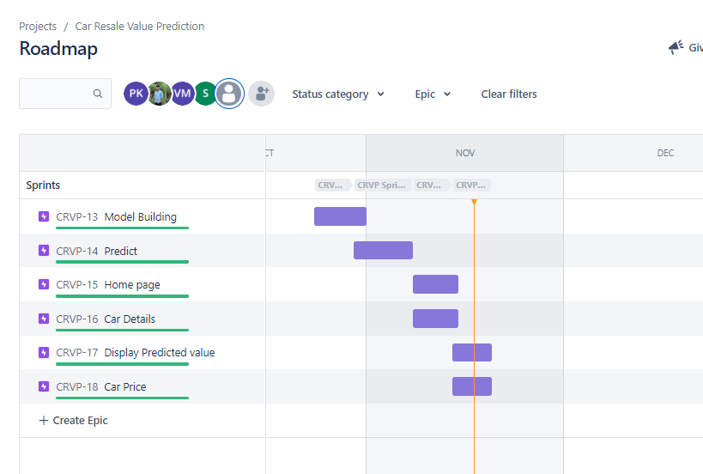

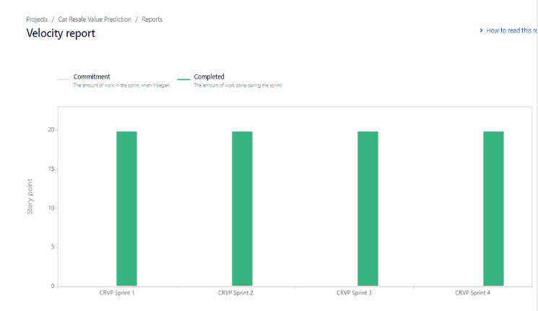

**CHAPTER 7**

**ADVANTAGES AND DISADVANTAGES**

**7.1 DEMERITS OF THE EXISTING SYSTEM:**

The data needed for the price estimation of the used cars is less in the existing system. Only variant , model, brand and the model year of the car and the estimated price of the car given by the seller are the only information given in most of the existing systems. In the existing systems, the owners of the cars code the selling price of the cars which is favorable to the owner’s hand. The satisfaction of the buyer and the seller is less and the estimated price isn’t reasonable. And the brokerage and brokers are involved in the existing systems. In the existing system, mechanics are needed to give the final estimate of the cars after the inspection. Mileage and horsepower are neglected in the price estimation data.

**7.2 MERITS OF THE NEWLY PROPOSED SYSTEM:**

The data needed for the price estimation of the used cars is more Compared to the existing system. Other than the variant , model and brand of the car , the mileage and Service records of the car is also needed for estimating price for greater accuracy . In the older or existing systems, the owners of the cars code the selling price of the cars which is favorable to the owner’s hand. The satisfaction of the both seller and buyer are more and there is no brokerage and brokers involved as an external mediator. User friendly, more reliable ,easily understandable , high accuracy in estimation of the price of used cars. There is less need for a mechanic to give a price estimate of the car after inspection. The more reasonable and best resale price is estimated through the newly proposed system which fulfills both the seller’s and buyer’s satisfaction.

**7.3 FEASIBILITY STUDY FOR USED CAR PRICE PREDICTION**

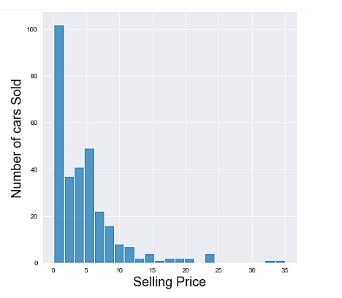

Data Science team and the development of a model that will provide the best results in revealing and preventing fraudulent transactions. This is achieved through bringing together all meaningful features of card users’ transactions, such as Date, User Zone, Product Category, Amount, Provider, Client’s Behavioral Patterns, etc. The information is then run through a trained model that finds patterns and rules so that it can classify whether a transaction is fraudulent or is legitimate.

**Creating idea of flow chart:**

                 Create ideas on how to model the project, how to design our project, where the selection will be placed and how it works. Draw the flow chart for making the implementation of our project.

**Implementation of idea:**

                 Implementing the idea of flow charts to make the project well. By searching some references in google we make this project as well as.

**Documentation:**

                 The documentation is completed after getting approval from the guide.

**7.4 PROJECT METHODOLOGY**

                 There are two primary phases in the system:

                                              1. Training Phase

                                              2. Testing Phase

**Training Phase:**

                      The system is trained by using the data in the data set and fits a model (line/curve) based on the algorithm chosen accordingly.

**Testing phase:**

                     The system is provided with the inputs and is tested for its working. The accuracy is checked. And therefore, the data that is used to train the model or test it, has to be appropriate. The system is designed to detect and predict the price of used cars and hence appropriate algorithms must be used to do the two different tasks. Before the algorithms were selected for further use, different algorithms were compared for its accuracy. The well-suited one for the task was chosen.

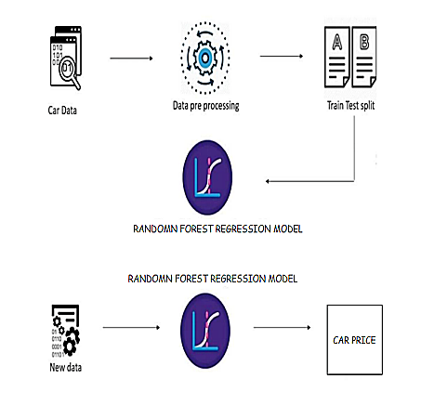

**7.5 MODULE DESCRIPTION**

**Data Pre-Processing:**

                 Data preprocessing is a process of preparing the raw data and making it suitable for a machine learning model. It is the first and crucial step while creating a machine learning model. When creating a machine learning project, it is not always a case that we come across clean and formatted data. And while doing any operation with data, it is mandatory to clean it and put it in a formatted way. So for this, the user can use data pre-processing task

**Training:**

                A training model is a dataset that is used to train an ML algorithm. It consists of the sample output data and the corresponding sets of input data that have an influence on the output. The training model is used to run the input data through the algorithm to correlate the processed output against the sample output. The result from this correlation is used to modify the model.

**Testing:**

             In machine learning, model testing is referred to as the process where the performance of a fully trained model is evaluated on a testing set. This kind of ML testing is more similar to traditional testing. Users can write and run tests checking the performance of the program. Applying the tests, users catch bugs in different components of the ML program. For example, users can test that the hidden layers in a neural network are configured correctly.

**Random forest Regression :**

               Random Forest Regression is a supervised learning algorithm that uses ensemble learning methods for regression. Ensemble learning method is a technique that combines predictions from multiple machine learning algorithms to make a more accurate prediction than a single model.

**Prediction:**

  “Prediction” refers to the output of an algorithm .It has been trained on a historical dataset and applied to new data when forecasting the likelihood of a particular outcome. Just like a hypothesis, a prediction is a type of guess. However, a prediction is an estimation made from observations.

**CHAPTER 8**

**TEST CASES**

**HOME PAGE Test Case:**

|  |  |  |  |  |  |  |
| --- | --- | --- | --- | --- | --- | --- |
| Test Case ID | Test Scenario | Test Case Description | Test Inputs | Expected Output | Positive Result | Negative Result |
| CRVP_TC_01 | Site link | To check whether the site link is open or not | Tap the site link | Visiblity of the website | When the website was opened after tap the site means the result as home page | When the website was not opened or  error acquiring like  402,505,etc.., |
| CRVP_TC_02 | Prediction button in  home page | To check whether the prediction is working or not | [Tap the button to open the prediction page](mailto:nitheeshkumarc2001@gmail.com,nitheeshkumarc@2001gmail.com) | Move to the prediction form | Successfully open the  prediction form | When the button was tapped by user error acquiring the frontend code connectivity code or button was not enabling , **Your file couldn’t be accessed** |

**PREDICTION FORM Test case:**

|  |  |  |  |  |  |
| --- | --- | --- | --- | --- | --- |
| Test Case ID | Test Scenario | Test Case Description | Test Inputs | Expected Output | Results |
| CRVP_TC_01 | Show room released year | To check whether the year was in the given limit | Input type Limited range of year | Prediction credational  is valid / Not valid | Test case will be pass / fail |
| CRVP_TC_02 | What is the Showroom Price?(In lakhs) | To check whether the Showroom Price? Is (In lakhs) | Car rate in lakh | Prediction credational  is valid / Not valid | Test case will be pass / fail |
| CRVP_TC_03 | How Many Kilometers Drived? | To check whether the kilometers were in given input  input format | Limited Kilometer as a  input | Prediction credational  is valid / Not valid | Test case will be pass / fail |
| CRVP_TC_04 | How much owners previously had the car(0 or 1 or 2) ? | To check whether the owner  limit is in range | Input type as number in given range | Prediction credational  is valid / Not valid | Test case will be pass / fail |
| CRVP_TC_05 | What Is the Fuel type? | To check whether the given  type of fuel is in scroll box option | To check whether the input is enable or not | Prediction credational  is valid / Not valid | Test case will be pass / fail |
| CRVP_TC_06 | Are you A Dealer  or Individual | To check whether the  option are utilized or not | Check the avaible option is visible or not | Prediction credational  is valid / Not valid | Test case will be pass / fail |
| CRVP_TC_07 | Transmission type | To verify the transmission type of the car | Check the both transmission is available or not | Prediction credational  is valid / Not valid | Test case will be pass / fail |
| CRVP_TC_08 | Calculate price button | Tap the button to predicted button | _ | _ | When the button was tapped by user error acquiring the frontend code connectivity code or button was not enabling , **Your file couldn’t be accessed** |

**OUTPUT Test case:**

|  |  |  |  |  |  |  |
| --- | --- | --- | --- | --- | --- | --- |
| Test Case ID | Test Scenario | Test Case Description | Test Inputs | Expected Output | Actual Output | Results |
| CRVP_TC_03 | Fianl output | To check whether the output  of predicted value | _ | Predicted value | Reviewed succesfully | Test case will be pass / fail |

**CHAPTER 9**

**RESULTS**

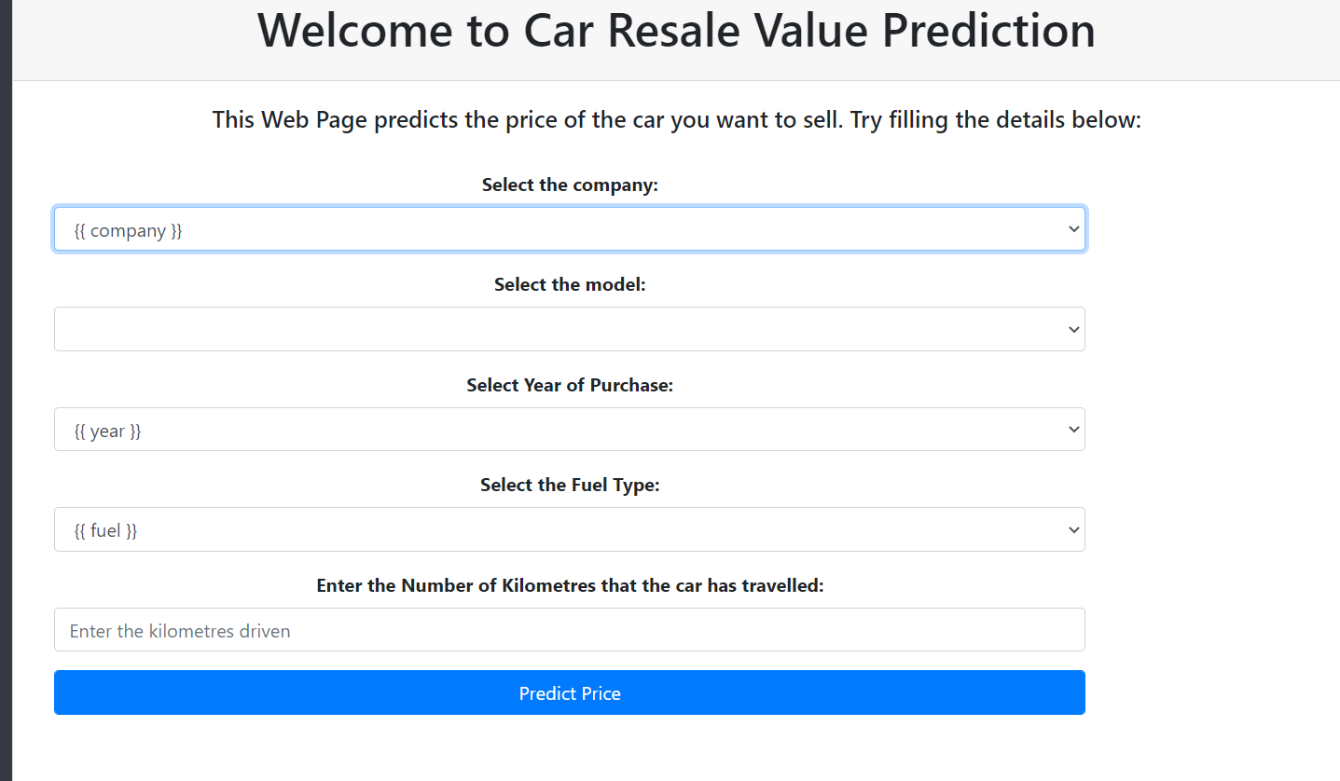

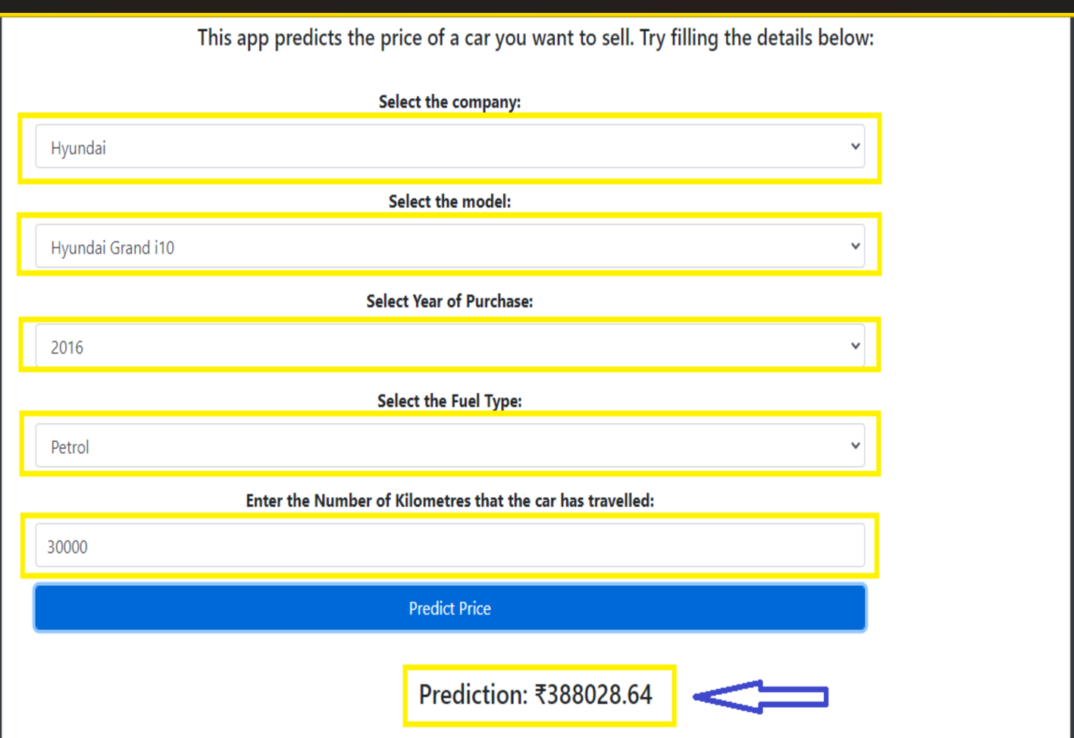

**CHAPTER 10**

**CODING AND SOLUTIONS**

**FEATURE 1**

## index.html

<!DOCTYPE html>

<http-methods>

<html lang="en">

<head xmlns="http://www.w3.org/1999/xhtml">

<meta charset="UTF-8">

<title>Car Price Predictor</title>

<link rel="stylesheet" href="static/css/style.css">

<link rel="stylesheet" type="text/css" href="https://cdnjs.cloudflare.com/ajax/libs/font-awesome/5.11.2/css/all.css"> <script src="https://ajax.googleapis.com/ajax/libs/jquery/3.4.1/jquery.min.js"></script> <script src="https://cdn.jsdelivr.net/npm/popper.js@1.16.0/dist/umd/popper.min.js" integrity="sha384-

Q6E9RHvbIyZFJoft+2mJbHaEWldlvI9IOYy5n3zV9zzTtmI3UksdQRVvoxMfooAo" crossorigin="anonymous"></script>

<!-- Bootstrap CSS --> <link rel="stylesheet"

href="https://stackpath.bootstrapcdn.com/bootstrap/4.5.0/css/bootstrap.min.css" integrity="sha384-

9aIt2nRpC12Uk9gS9baDl411NQApFmC26EwAOH8WgZl5MYYxFfc+NcPb1dKGj7Sk" crossorigin="anonymous">

<script src="https://cdn.jsdelivr.net/npm/@tensorflow/tfjs@2.0.0/dist/tf.min.js"></script>

</head>

<body class="bg-dark">

<div class="container">

<div class="row">

<div class="card mt-50" style="width: 100%; height: 100%">

<div class="card-header" style="text-align: center">

<h1>Welcome to Car Resale Value Prediction</h1>

</div>

<div class="card-body">

<div class="col-12" style="text-align: center">

<h5>This Web Page predicts the price of the car you want to sell. Try filling the details below: </h5>

</div>

<br>

<form method="post" accept-charset="utf-8" name="Modelform">

<div class="col-md-10 form-group" style="text-align: center">

<label><b>Select the company:</b> </label><br>

<select class="selectpicker form-control" id="company" name="company" required="1"

onchange="load_car_models(this.id,'car_models')">

{% for company in companies %}

<option value="{{ company }}">{{ company }}</option>

{% endfor %}

</select> </div>

<div class="col-md-10 form-group" style="text-align: center">

<label><b>Select the model:</b> </label><br>

<select class="selectpicker form-control" id="car_models" name="car_models" required="1">

</select> </div>

<div class="col-md-10 form-group" style="text-align: center">

<label><b>Select Year of Purchase:</b> </label><br>

<select class="selectpicker form-control" id="year" name="year" required="1"> {% for year in years %}

<option value="{{ year }}">{{ year }}</option>

{% endfor %}

</select> </div>

<div class="col-md-10 form-group" style="text-align: center">

<label><b>Select the Fuel Type:</b> </label><br>

<select class="selectpicker form-control" id="fuel_type" name="fuel_type" required="1">

{% for fuel in fuel_types %}

<option value="{{ fuel }}">{{ fuel }}</option> {% endfor %}

</select> </div>

<div class="col-md-10 form-group" style="text-align: center">

<label><b>Enter the Number of Kilometres that the car has travelled:</b> </label><br>

<input type="text" class="form-control" id="kilo_driven" name="kilo_driven" placeholder="Enter the kilometres driven "> </div>

<div class="col-md-10 form-group" style="text-align: center">

<button class="btn btn-primary form-control" onclick="send_data()">Predict

Price</button>

</div>

</form>

<br>

<div class="row">

<div class="col-12" style="text-align: center">

<h4><span id="prediction"></span></h4>

</div>

</div>

</div>

</div>

</div>

</div>

<script>

function load_car_models(company_id,car_model_id)

{

var company=document.getElementById(company_id); var car_model= document.getElementById(car_model_id);

console.log(company.value); car_model.value=""; car_model.innerHTML=""; {% for company in companies %}

if( company.value == "{{ company }}")

{

{% for model in car_models %}

{% if company in model %}

var newOption= document.createElement("option");

newOption.value="{{ model }}"; newOption.innerHTML="{{ model }}";

car_model.options.add(newOption);

{% endif %}

{% endfor %}

}

{% endfor %}

}

function form_handler(event) {

event.preventDefault(); // Don't submit the form normally

}

function send_data()

{

document.querySelector('form').addEventListener("submit",form_handler);

var fd=new FormData(document.querySelector('form'));

var xhr= new XMLHttpRequest({mozSystem: true});

xhr.open('POST','/predict',true);

document.getElementById('prediction').innerHTML="Wait! Predicting Price....."; xhr.onreadystatechange = function(){ if(xhr.readyState == XMLHttpRequest.DONE){ document.getElementById('prediction').innerHTML="Prediction:

₹"+xhr.responseText;

}

};

xhr.onload= function(){};

xhr.send(fd);

}

</script>

<!-- jQuery first, then Popper.js, then Bootstrap JS -->

<script src="https://code.jquery.com/jquery-3.5.1.slim.min.js" integrity="sha384-

DfXdz2htPH0lsSSs5nCTpuj/zy4C+OGpamoFVy38MVBnE+IbbVYUew+OrCXaRkfj" crossorigin="anonymous"></script>

<script src="https://cdn.jsdelivr.net/npm/popper.js@1.16.0/dist/umd/popper.min.js" integrity="sha384-

Q6E9RHvbIyZFJoft+2mJbHaEWldlvI9IOYy5n3zV9zzTtmI3UksdQRVvoxMfooAo" crossorigin="anonymous"></script>

<script src="https://stackpath.bootstrapcdn.com/bootstrap/4.5.0/js/bootstrap.min.js" integrity="sha384-

OgVRvuATP1z7JjHLkuOU7Xw704+h835Lr+6QL9UvYjZE3Ipu6Tp75j7Bh/kR0JKI" crossorigin="anonymous"></script>

</body>

</html>

## style.css

.{

margin: 0; padding: 0;

box-sizing: border-box;

}

.bg-dark{

}

.mt-50{

margin-top: 50px;

}

#canvas{

border: 2px solid black;

}

**FEATURE 2**

## Resale_flask.py

from flask import Flask,render_template,request,redirect from flask_cors import CORS,cross_origin

import pickle import pandas as pd

import numpy as np

app=Flask(__name__) cors=CORS(app)

model=pickle.load(open('RandomForest.pkl','rb')) car=pd.read_csv('Cleaned.csv')

@app.route('/test',methods=['GET','POST']) def index():

companies=sorted(car['company'].unique()) car_models=sorted(car['name'].unique()) year=sorted(car['year'].unique(),reverse=True) fuel_type=car['fuel_type'].unique()

companies.insert(0,'Select Company')

return render_template('index.html',companies=companies, car_models=car_models, years=year,fuel_types=fuel_type)

@app.route('/predict',methods=['POST'])

@cross_origin() def predict():

company=request.form.get('company')

car_model=request.form.get('car_models') year=request.form.get('year') fuel_type=request.form.get('fuel_type')

driven=request.form.get('kilo_driven')

prediction=model.predict(pd.DataFrame(columns=['name', 'company', 'year', 'kms_driven',

'fuel_type'], data=np.array([car_model,company,year,driven,fuel_type]).reshape(1, 5))) print(prediction)

return str(np.round(prediction[0],2))

if __name__=='__main__':

app.run()

**CHAPTER 11**

**11.1 CONCLUSION AND SCOPE FOR FUTURE WORK**

The increased prices of new cars and the financial incapability of the customers to buy them, Used Car sales are on a global increase. Therefore, there is an urgent need for a Used Car Price Prediction system which effectively determines the worthiness of the car using a variety of features. The proposed system will help to determine the accurate price of used car price prediction . Car Price Prediction was aimed to get different perspectives and eventually compared their performance with different models. Car price prediction can be a challenging task due to the high number of attributes that should be considered for the accurate prediction. The major step in the prediction process is collection and preprocessing of the data. In this research, linear regression and lasso regression , Random forest regression were built to normalize, standardize and clean data to avoid unnecessary noise for machine learning algorithms. Data cleaning is one of the processes that increases prediction performance.

**GITHUB LINK :** https://github.com/IBM-EPBL/IBM-Project-49675-1660833562

**DEMO LINK:** https://drive.google.com/file/d/1nNIieEONXCddvqld8nnvuOS_7yx4FVGQ/view?usp=share_link

**REFERENCE**

[1] Agency za statistiku BiH. (n.d.), retrieved from http://www.bhas.ba.[accessed July 18, 2018.]

[2] Listiani, M. (2009). Support vector regression analysis for price prediction in a car leasing application (Doctoral dissertation, Master thesis, TU Hamburg-Harburg).

[3] Wu, J. D., Hsu, C. C., & Chen, H. C. (2009). An expert system of price forecasting for used cars using adaptive Neuro-fuzzy inference. Expert Systems with Applications, 36(4), 7809-7817.

[4] Du, J., Xie, L., & Schroeder, S. (2009). Practice Prize Paper—PIN Optimal Distribution of Auction Vehicles System: Applying Price Forecasting,Elasticity Estimation, and Genetic Algorithms to Used-Vehicle Distribution.Marketing Science, 28(4), 637-644.